Maithreem Bhajatha

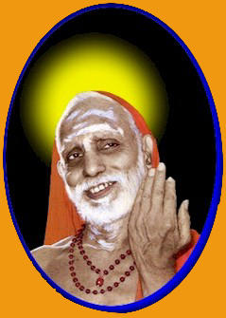

This song was written by Jagathguru Shankaracharya Sri Chandrashekarendra Saraswathi Swamigal of Kanchi Kamakoti Peetam. He was also famously known as ‘MahaSwami’, 'MahaPeriyavaa', or 'Paramacharya'. The occasion was the 50th anniversary of United Nations Organization (U.N.O.). The Queen of Carnatic Music, Bharath Rathna Smt. M.S. Subbulakshmi was invited to perform at U.N.O. When she mentioned this to the Paramacharya and sought His Blessings, He offered His Benediction and gave her this Sanskrit song, which she rendered to rave reviews at the U.N.O. , as well as all over the world since. This song has since been adopted and rendered by many artists and is sung as the International Anthem for peace and harmony.

Maithreem Bhajatha Akila Hrith Jeththreem - Serve with Friendship and Humility, which will conquer the Hearts of Everyone.
Atmavat Eva Paraan api Pashyata - Look upon others similar to yourself.
Yuddham Tyajata - Renounce War
Spardhaam Tyajata - Renounce unnecessary Competition for Power
Tyajata Pareshwa akrama aakramanam - Give up Aggression on others' properties which is wrong
Jananee Prthivee Kaamadughaastey - Mother Earth is wide enough and ready to give us all we desire like a Kaamadenu
JanakO Deva: Sakala Dayaalu: - God, Our Father, is very Compassionate to All
Daamyata - So, Restrain yourself
Datta - So, Donate your wealth to others
Dayathvam - So, Be Kind to others
Janathaa: - Oh People of the World
Sreyo Bhooyaath Sakala Janaanaam - May All People of this World be Happy and Prosperous.
Sreyo Bhooyaath Sakala Janaanaam - May All People of this World be Happy and Prosperous.
Sreyo Bhooyaath Sakala Janaanaam - May All People of this World be Happy and Prosperous.

